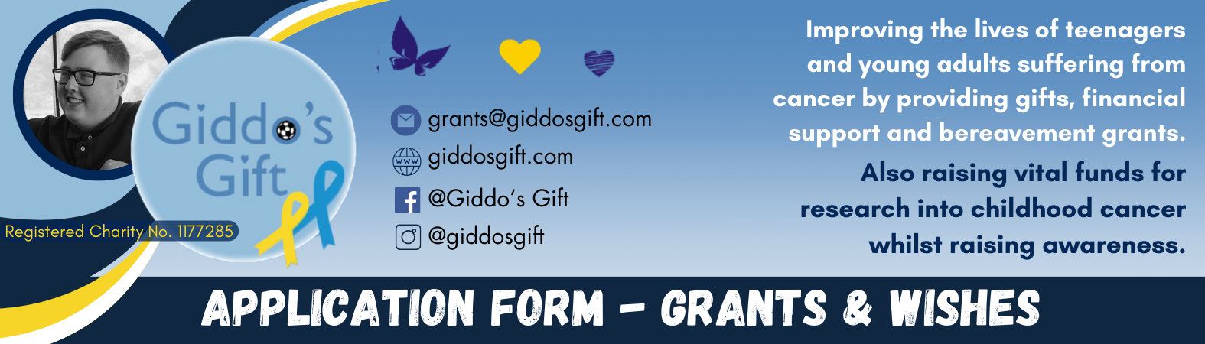
CATION FORM
NAME DATE OF BIRTH / AGE

ADDRESS (including postcode)

TELEPHONE MOBILE

EMAIL

DIAGNOSIS DATE OF DIAGNOSIS

MEDICAL HISTORY

THE CHARITABLE TRUST’S OBJECTIVE 1
The relief of sickness and the preservation of health among teenagers and young adults aged 13-24 years suffering with cancer within North West England and North Wales by the provision of items/gifts and financial support to enable them to keep in touch with friends whilst undergoing treatment.

Please select one category below to indicate whether you are applying for
(Please tick one only)
 GIFT
Write your choices i.e. laptop, phone, trainers etc

 WISH
Write your choices i.e. cinema outings, festivals, meals with friends

FINANCIAL GRANT
Please indicate value of grant and purpose of grant

PLEASE TELL US ABOUT YOURSELF:
About you and your medical history, treatments and treatment schedule
As much information as possible to support your application

DETAILS OF REFEREE
Please provide details of one referee who is prepared to support the application. PLEASE NOTE: This needs to be a medical professional looking after your care such as your Consultant CLIC Sargent Social Worker, Support Worker or Nurse.

Contact details for your referee:
NAME JOB TITLE

ADDRESS including postcode

EMAIL PHONE

Please tell us how you found out about our work. Where did you hear about us?

If a financial grant is requested, please provide your bank details should your application be successful.
Bank Name:

Sort Code (six digits): Account Name: Account Number:

Please provide details of all previous application(s) made to Giddo’s Gift, including date(s) and whether or not the application(s) was/were successful.

Please note that if you are under 18 years of age this form must be verified by your parent or guardian.To the best of my knowledge all the information provided on this application is correct. I give permission to Giddo’s Gift Charitable Trust to record the information given in this form electronically and to contact me by telephone, post or email in connection with this application and if my application is successful, to give details of the grant on it’s website, social media,
annual report etc.
I confirm that I have read and understood the Giddo’s Gift Grant-Making Policy.
I agree to advise the Giddo’s Gift Charitable Trust immediately if, at any time, before an award is made to me, there are significant changes in the information given by me on this form.

APPLICANT’S NAME (or name of parent/guardian if applicable)

DATE

Thank you for completing this form. Please send via email to grants@giddosgift.com

